**System Block Diagram**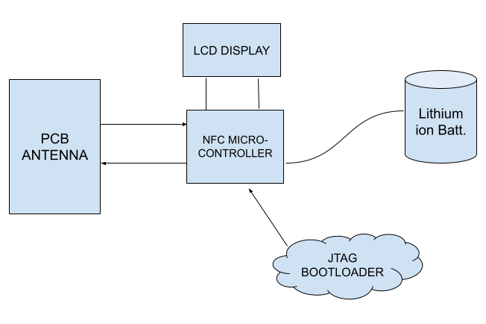

Transmitter Circuit: Receiver Circuit:

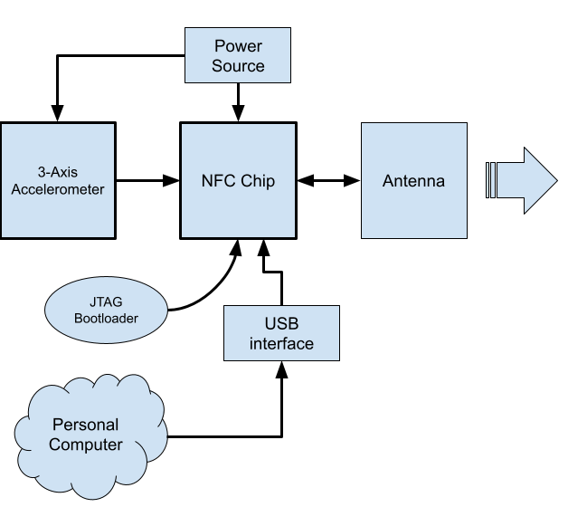

**Block Descriptions**

**Transmitter:**

**3-Axis Accelerometer sensor:** Triple axis MEMs accelerometer sensor that reports real time acceleration in x, y and z directions. The accelerometer sensor output is fed into the digital inputs of the NFC microcontroller. Digital accelerometer can use both I2C and SPI input pins, and we will need to decide which protocol to use based on the simplicity of its integration.

Inputs: 3-axis acceleration, power, SPI/I2C designator

Outputs: Acceleration data

**TI NFC microcontroller:** The NFC microcontroller receives the accelerometer signal, determines the composite vector of acceleration, and then radiates it on the LC bank connected to the output of the chip. It also records sensor data for the previous 5 seconds into on-board memory. To use this, we need a bootloader and a usb interface to program it. This is a low power microcontroller which requires very little power to operate.

Inputs: I2C pins, Digital accelerometer data, JTAG pins, programs, power, USB

Outputs: antenna pins, I2C data how

**Power supply:** A rechargeable Lithium ion battery of 500mAh or more will be used to power the NFC chip and the accelerometer. We could potentially use a capacitor with a voltage regulator if we decide that a lithium battery is too large. For recharging, we will use a power supply to charge the LiPo battery when needed. The NFC chip also supports inductive power harvesting through its antenna inputs but we need to determine if this is a viable option worthy of the prototyping time.

Inputs: Charging wires

Outputs: Power at 3.7V

**Antenna:** The antenna is a basic magnetic field antenna and we intend to use a copper trace on the PCB to create it. However, we need to use a software package with KiCAD to design the length and shape of the copper trace. The capacitor component will likely be a smd capacitor to create the LC bank. Data will ideally be transmitted in alternating bursts of accelerometer data and identification data.

Inputs: Modulated NFC data, possible power harvesting

Outputs: Antenna return path

**JTAG Bootloader:** The TI NFC chip will need to be loaded with a basic operating system so that it can be programmed. This is done easily with the 4 JTAG pins on the IC.

Inputs: USB connection

Outputs: JTAG pins 19-22

**Receiver:**

**Antenna:**The antenna is a basic magnetic field antenna and we intend to use a copper trace on the PCB to create it. However, we need to use a software package with KiCAD to design the length and shape of the copper trace. The capacitor component will likely be a smd capacitor.

**Front End:** The NFC controller is integrated with an RF Level detector and a highly integrated demodulator and decoder which serve as the main front end circuitry components. More characterization of the NFC controller will be done and details of that provided in the future reports.

**NXP NFC controller module:** The receiver NFC controller consists of a 80C51 microcontroller core that processes the received data such as converting the data information into a force variable and storing this data. The microcontroller should also resolve the multiplexed signals from different transmitters into different variables. The processed data is sent to the output pins where it will be displayed by the LCD display.

Inputs: RX pins -> RF input from PCB antenna

Outputs: TX1, TX2 pins -> digital outputs of the processed data that will be sent to the LCD display

**Display:** An LCD display will be used to display the acceleration data from the microcontroller. This will likely be a simple 32 pixel display to show data and will be programmed using the USB interface of the microcontroller.

Inputs: I2C data from microcontroller

Outputs: Text

**Power supply:** We will use a 2000mAh power supply connected with a USB charging module for easy recharging and operation.

Inputs: USB charging module, charging wires

Outputs: Power at 3.7 volts

**Test Points and Evaluation**

Some iteration on the antenna design will likely be necessary. To do this, we will fabricate a PCB with just the antenna and validate the performance of the antenna using a vector network analyzer.

Additionally, we will perform a test integration of the transmitter amd reciever NFC modules using an adaptor PCB and an accelerometer module on a solderless breadboard.